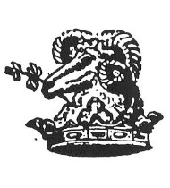
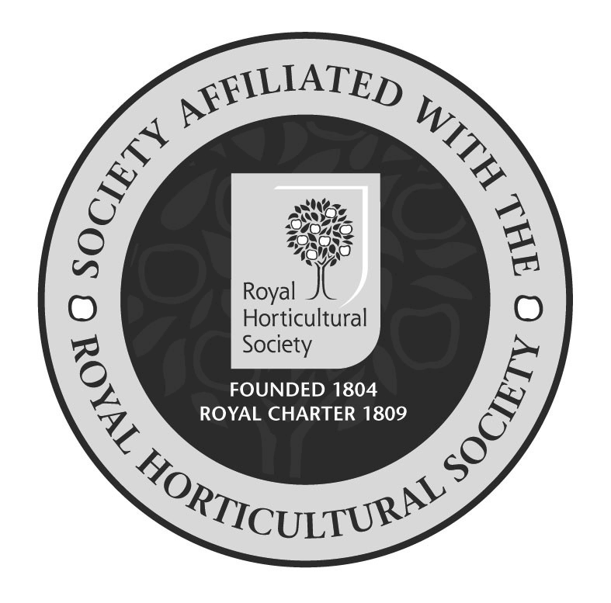
Disley & Lyme
Horticultural Society
MEMBERSHIP APPLICATION

Members will get society newsletters & updates, discounts on compost sales, 30% savings on Dobies seeds, and discounts at the society show and on society trips , so you should easily recover your subscription fee.

Check out our website dlhs.weebly.com

To join simply fill in and return this form in at any of our events or send the form to davidedmondson11@gmail.com with remittance ideally paid direct to Disley & Lyme Horticultural Society Bank Account Sort Code 01-03-87 Account number 30771676

**please use your name as the payment reference**

NAME (Block letters please):

Address

& Post code

email address

& phone number

I enclose subscriptions for Adults @ £5 each Total remittance: £

Bank Payment Yes / No (Delete as appropriate)

Alternatively pay your subscription at any of our events making any cheques payable to Disley & Lyme Horticultural Society

Don’t forget to advise us if you change your email address, if you don’t, we can’t send you newsletters and the like

General Data Protection Act 2018
I/we consent to my/our personal data being stored and used solely for the purposes of the DLHS activities and membership.
I/we understand the data will be collected and processed in accordance with General Data Protection Regulations 2108, and that personal information will not be disclosed to any third party
Please strike through to confirm your consent. Yes / No
Please pass this form along to anyone you think may be interested in joining the society

2023 subscriptions run to 31st March 2024
Membership application 2023

